Exp 6 main

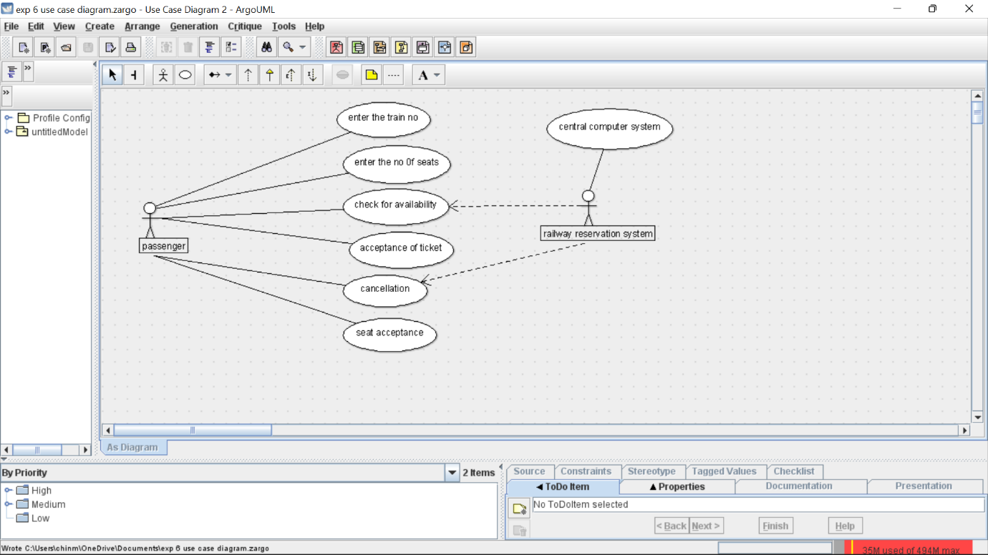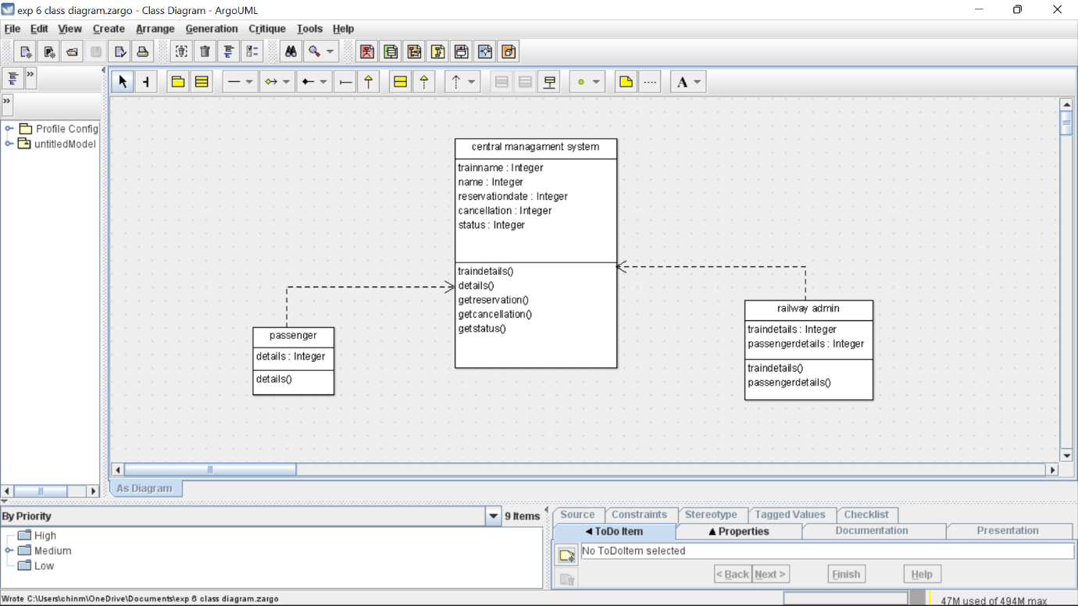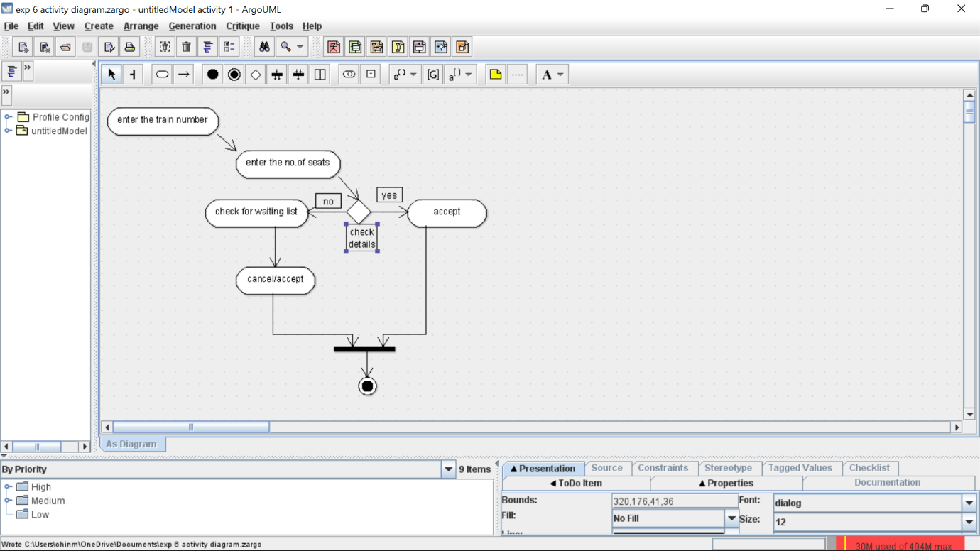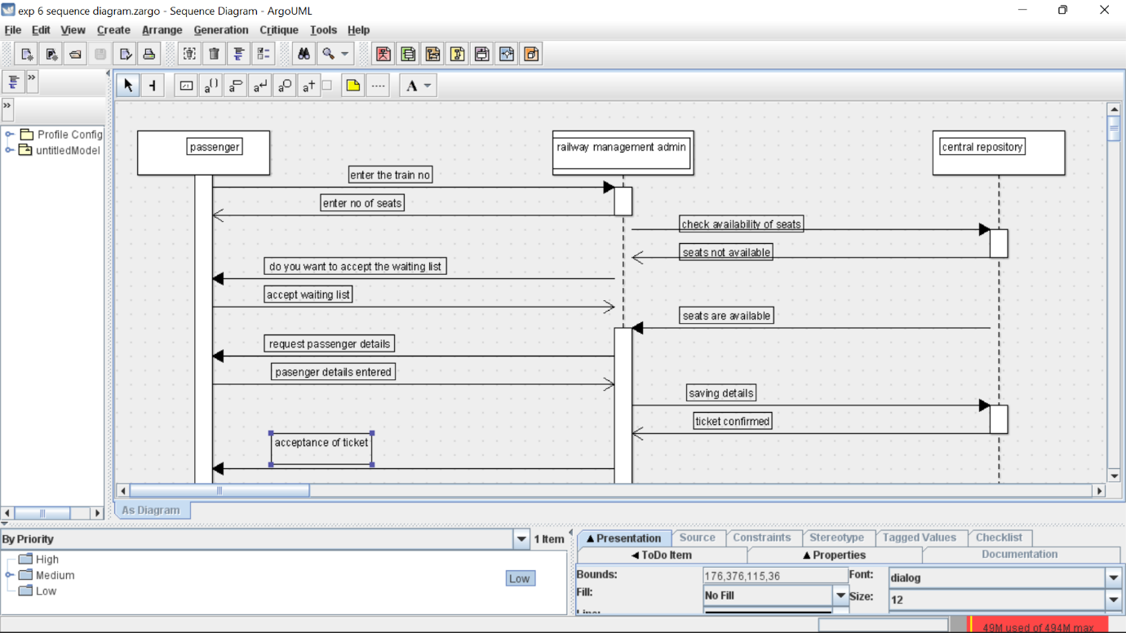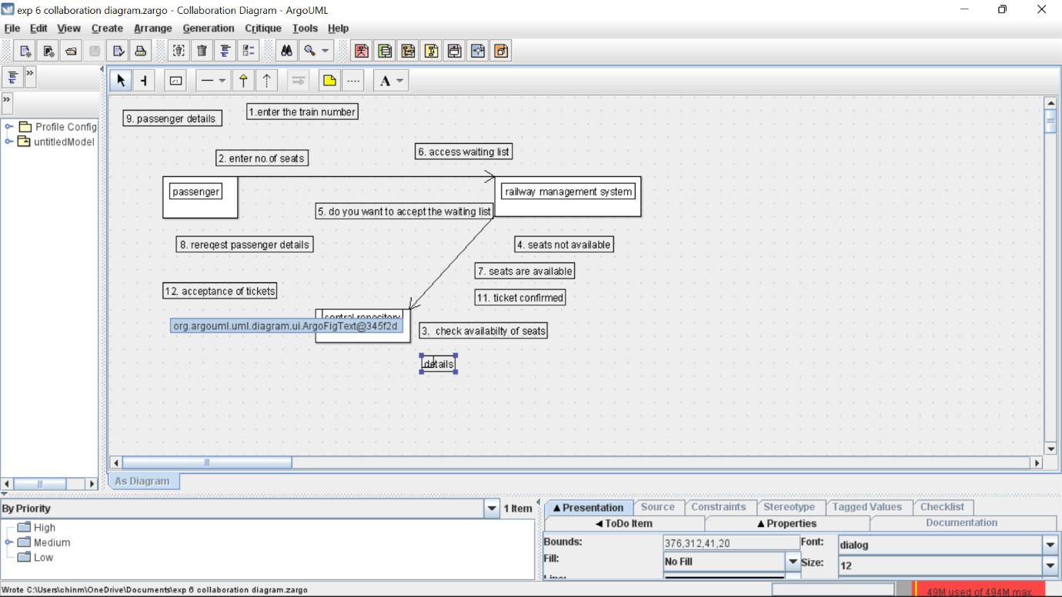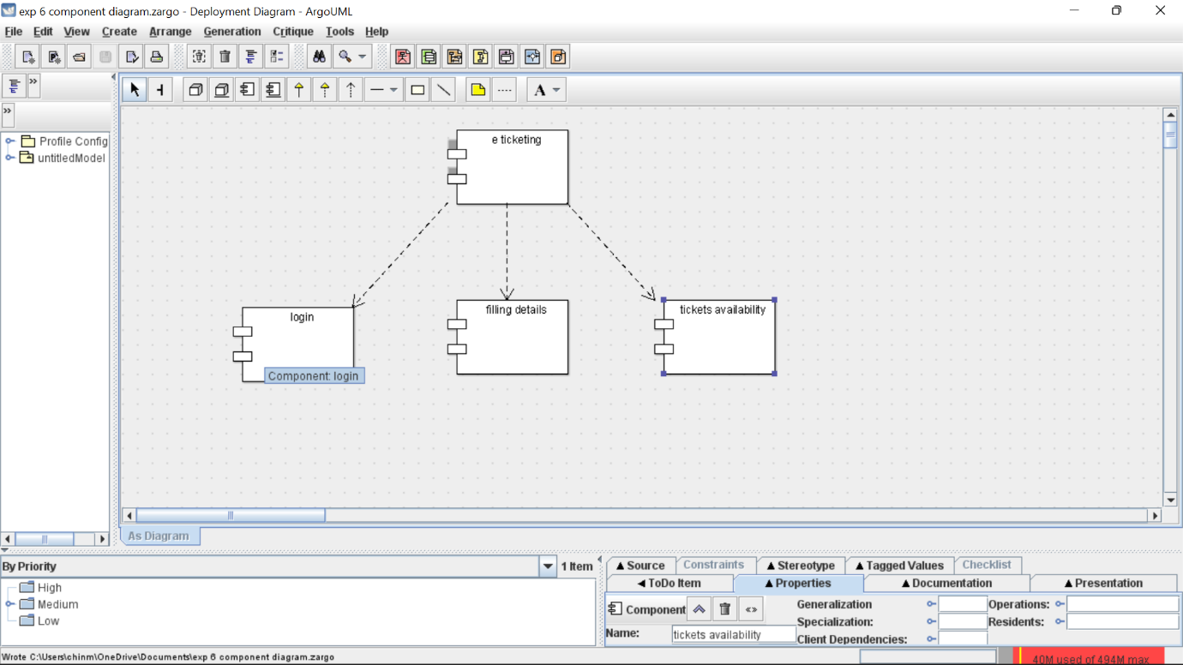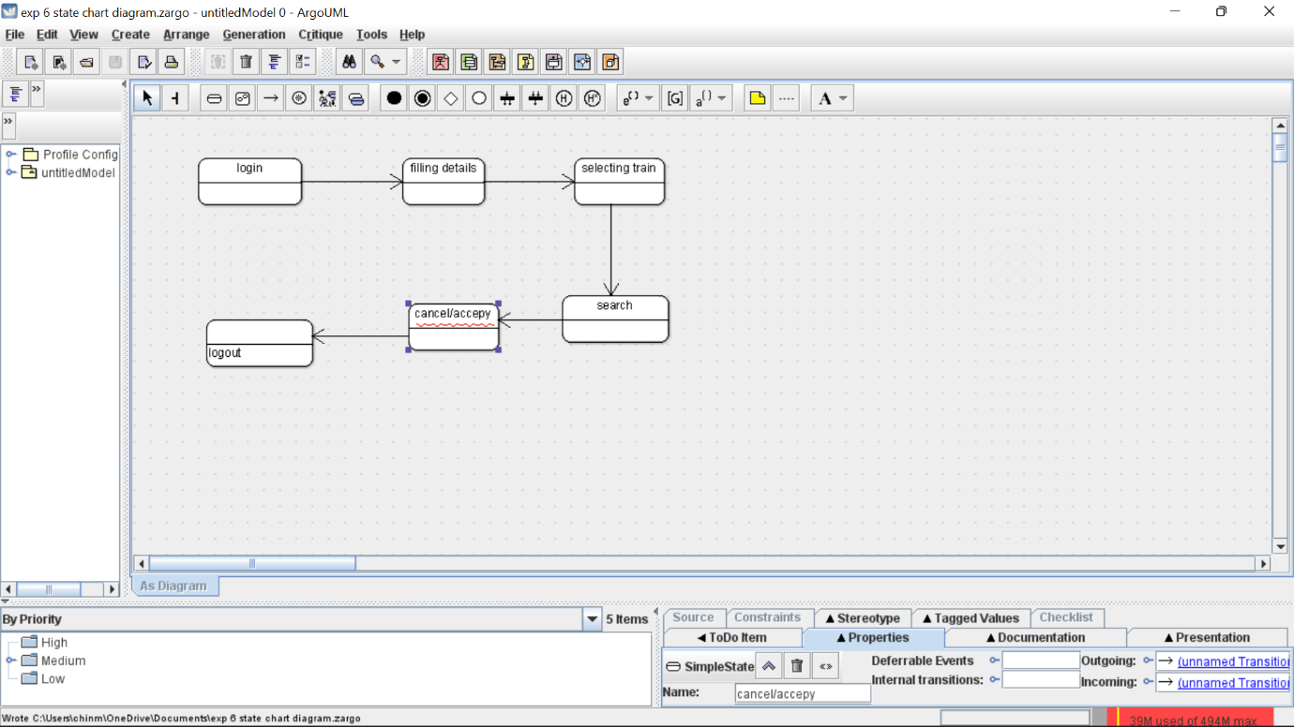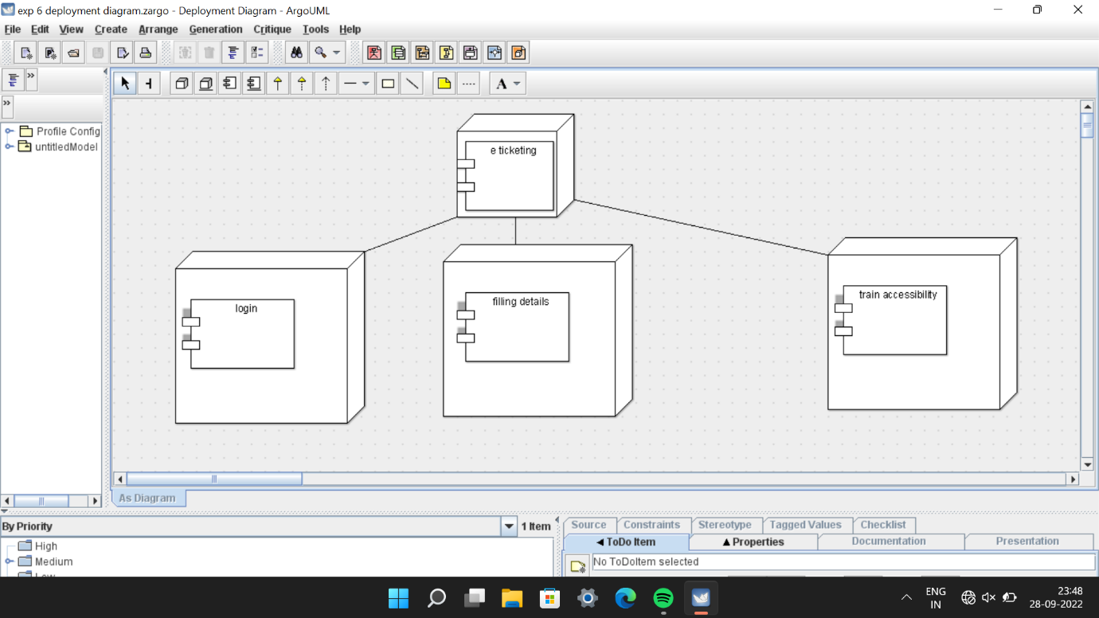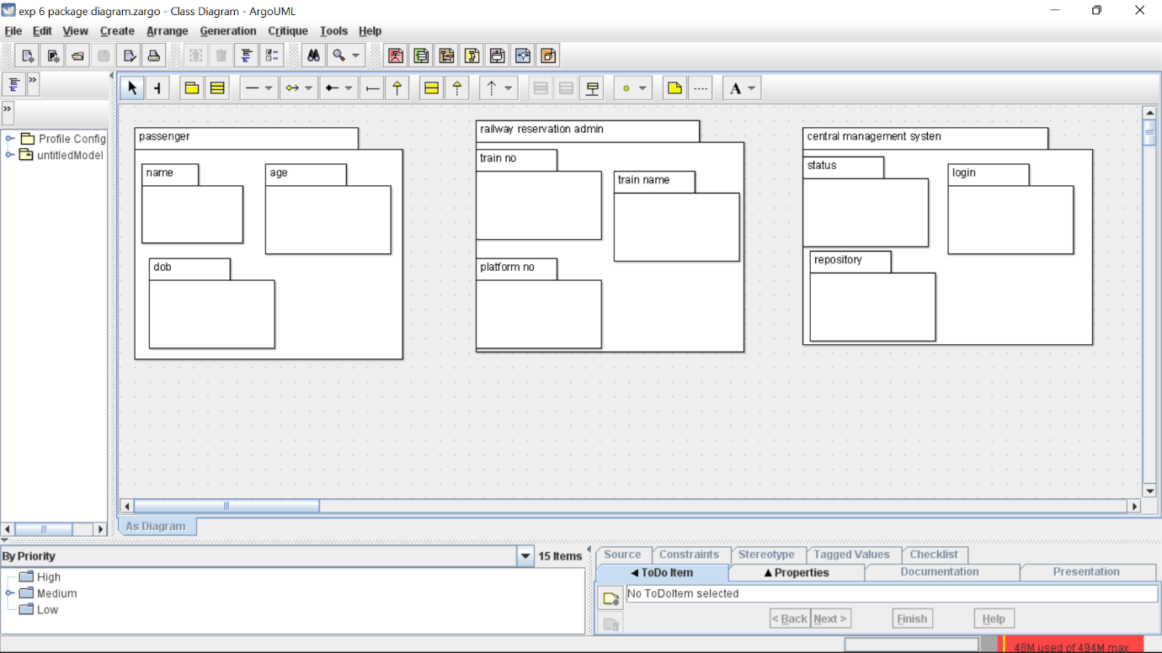

Skeleton code

public class CENTRAL MANAGEMENT SYSTEM {

public Integer SELECT;

public Integer VERIFY;

public void VERIFY() {

}

public void ENROLL() {

}

}

public class STUDENT {

public Integer NAME;

public IntegerADDRESS ADDRESS;

public Integer NUMBER;

public void MATHS() {

}

public void SCIENCE() {

}

}

public class UNIVERSITY ADMIN {

public Integer STOREDETAILS;

public Integer VERIFYDETAILS;

public void FEE() {

}

public void ENROLL() {

}

}